Management Instruction for Tooling Periodic Inspection for Boeing Program

- Scope

This management instruction specifies the requirements for tooling periodic inspection.
This management instruction is applicable to Boeing program production (except B787).
This management instruction is developed in accordance with requirements of GLC14070305 and D33200-1.

- Reference Documents

D33200-1 Boeing Supplier's Tooling
GLC14070305 Management Procedure for Tooling Periodic Inspection
GLC231007 Management Procedure for Development of Technical Document
GLC231008 Management Procedure for Quality Records

3 Form

3.1 Prescribed Form
None
3.2 Referenced Form
FM1407-52 Frequency Determination Request for Periodic Tooling Inspection

- Terms and Definitions

4.1 Periodic Tooling Inspection Plan (PTI Plan)/ Periodic Tooling Inspection Record
The documents prepared based on the function and design of tooling are the basis for periodic inspection of tooling. It includes the periodic inspection contents and theoretical data of tooling, and is also used to record the measurement data and inspection results of periodic inspection of tooling.
When it is used as the basis for periodic inspection of tooling, it is called periodic inspection plan of tooling. It is called periodic check record of tooling when it is used to record the data and inspection results of periodic inspection of tooling and attached with the report issued by measuring equipment.

- Regulations

5.1 All the Category II tooling must be periodic inspected.
5.2 Category II tooling for product and inspect need to perform inspection for the first 3 consecutive ship set until the stability of the tooling is verified, then the tooling shall be periodic inspected per the periodic cycle time. According to the tooling experience, stability, function and design tooling periodic inspection cycle time initial determined and subsequent changes, must be approved by Boeing, using the FM 1405-52 to ask for the customer to approve the periodic inspection cycle.
5.3 Periodic checking cycle time is no more than 6 months. The cycle time of PTI for Category II tooling is no more than 12 months.
5.4 For all class II tooling used for production and inspection, a tooling periodic inspection plan shall be prepared separately by technician in Tooling Office. The tooling periodic inspection plan shall be in Chinese and English, and the data unit is inch. The tooling periodic inspection plan shall be submitted to the customer for approval when the initial manufacturing and inspection of the tooling are completed, and the customer shall be informed of the time of the first tooling periodic inspection.
5.5 Tooling periodic inspection plan should be submitted to customers for approval when upgrading.
5.6 The elements included in tooling periodic inspection are A-O, and the elements included in tooling periodic check are A-H. See Appendix A for the layout and filling of tooling periodic inspection/check plan.
A. Revision of PTI plan.
B. Boeing tooling number.
C. Boeing lifetime serial number.
D. Tooling unit number.
E. Integrity of tooling parts.
F. Conformity between tooling object and latest Tooling Design Revision.
G. Tooling level and verticality requirements applicable to tooling periodic inspection / periodic check specified in tooling design.
H. Visual inspection for damage, wear and foreign object debris.
I. Temperature of tooling during PTI.
J. Tooling characteristics compatible with master tooling
K. Digital measurement of features such as optical tooling points, enhanced reference points, indexed, I/R features and any other critical dimensions per the tooling design.
L. “ Before” and “After” adjustment readings.
M. Area to log tooling non-conformances for out of tolerance conditions.
N. Before and after survey scale measurements (for CMS controlled tooling).
O. PTI tolerances: Tolerances used for PTIs must be in accordance with the tooling design requirement.
5.7 The technician in Tooling Office will upload the tooling periodic inspection plan to the CPM platform for management. The path is "Boeing general > Technological Innovation Department > Tooling Office > Self Prepared Technical Documents>Plan of Periodic Tooling Inspection and Check". During periodic tooling inspection, The operator will transmit the latest version of the periodic tooling inspection plan to the periodic tooling inspection. When accepting the tooling, the inspector of tooling user shall confirm that the tooling is periodic inspected according to the latest version of the periodic tooling inspection plan.
5.8 If an earthquake occurs within a radius of 50 miles, or natural disasters (such as hurricanes, floods, tornadoes, etc.) or man-made disasters may affect the use of tooling, The operator of periodic tooling inspection in tooling user contacts the Boeing tooling manager for guidance for relevant tooling that needs to be periodic inspected or periodic checked.

6 Standard Legend Description
None

7 Record Control

7.1 Fill in and maintain relevant records according to GLC231008.
7.2 The PTI’s record shall be stored ten years at least.

附录A
Appendix A
（资料性附录）
Definitive Appendix
工装定检/定查计划（工装定期检查记录）的排版与填写要求
Layout and filling requirements of PTI plan(tooling periodic inspection plan)
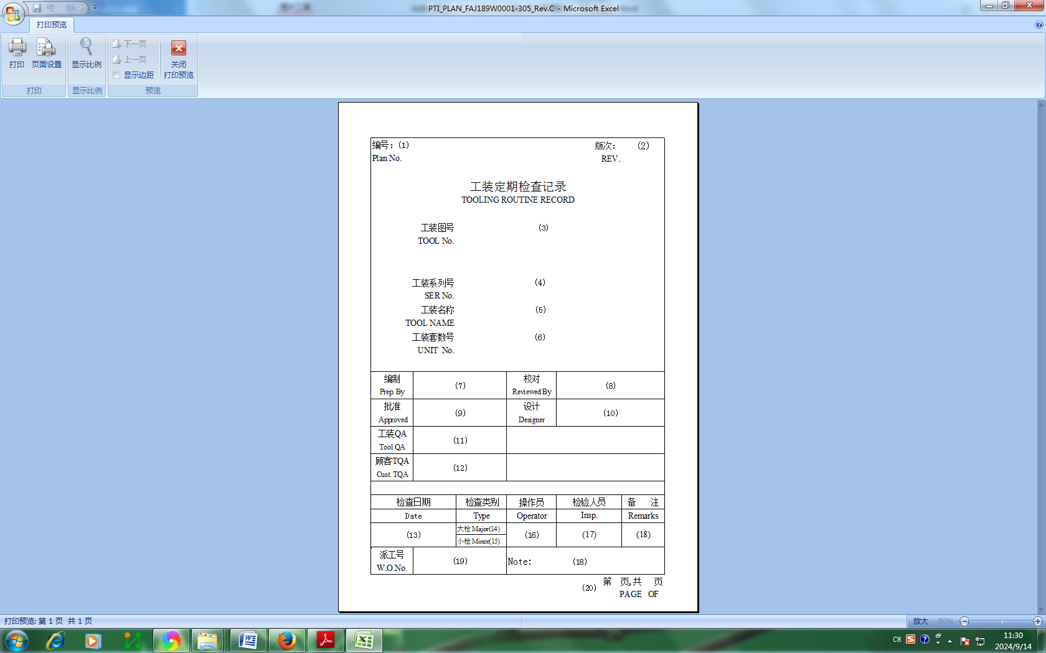
A.1 填表说明 Filling Instructions
（1）～（6）、（18）、（20）由工艺装备室技术员填写。
(1) ~ (6) ，（18），（20）shall be filled in by the technician of Tooling Office.
（1）：按GLC231007进行编号。
（2）：填写工装定期检查记录的版次，版次符号用大写的英文字母NEW、A～Y表示（其中I、O、Q、S、X不得使用），当A～Y不够用时，可按AA～AY，BA～BY、...的次序使用。
（3）：填写工装图号。
（4）：填写工装系列号。
（5）：填写中、英文的工装名称。
（6）：填写工装套数号。
（7）：工装定检计划的编制人员签字并注明日期。
（8）：工装定检计划的校对人员签字并注明日期。
（9）：如工装定检计划由工艺装备室技术员组织供应商编制，工艺装备室技术员在此栏签字并注明日期。如工装定检计划由工艺装备室技术员编制，工艺装备室主任在此栏签字并注明日期。
（10）：工装设计人员签字并注明日期。
（11）：工装定检检验/验收或工装定查合格时，工装定检检验/验收的检验人员或定查实施人员进行签字/盖章并注明日期。
（12）：如顾客签字审批，在此栏签字。
（13）：工装定检/定查的实施人员填写工装定检/定查的完成时间。
（14）：工装定检操作者在“大检Major”后面打“√”。
（15）：工装定查实施人员在“小检Minor”后面打“√”(小检即定查)。
（16）：工装定检操作者签字并注明日期。对于工装定查，如测量工装水平/垂直，此栏由工装水平/垂直的测量人员签字并注明日期。如不测量装水平/垂直，定查实施人员在此栏填写“N/A”。
（17）：工装定检/定查的检验人员盖章并注明日期。
（18）：填写定检和定查涉及的页次信息及其它按需备注信息。
（19）：工装定检操作者填写派工号。对于工装定查，工装定查实施人员在此栏填写“N/A”。
（20）：填写页次信息，本页为第1页。
（1）～（10）、（18）、（20）栏填写完成后，工装使用单位工装检验人员可将本页保存，后续每次定检/定查复制使用本页。
(1): Number per GLC231007.
(2): Fill in the revision of tooling periodic check record. The revision symbol is represented by capital English letters NEW, A ~ Y (I, O, Q, S and X shall not be used). When A ~ Y is not enough, it can be used in the order of AA ~ AY, BA ~ BY.
(3): Fill in the tooling drawing number.
(4): Fill in the tooling serial number.
(5): Fill in the name of tooling in Chinese and English.
(6): Fill in the number of tooling sets.
(7): Signed and dated by the person who prepared the tooling periodic inspection plan.
(8): Signed and dated by the proofreader of tooling periodic inspection plan.
(9): If the periodic inspection plan of tooling is prepared by the supplier, the technician in Tooling Office shall sign and indicate the date in this column. If the periodic inspection plan of tooling is prepared by the technician of Tooling Office, the director of Tooling Office shall sign and date in this column.
(10): Signed and dated by Tooling Designer.
(11): When inspecting/ accepting the periodic inspection or check of tooling, the tooling inspector/ acceptance personnel or personnel performing periodic check shall sign / seal and indicate the date.
(12): If the customer signs for approval, sign in this column.
(13): The operator of tooling periodic inspection/check shall fill in the completion time of tooling periodic inspection/check.
(14): Tooling periodic inspection operator shall mark "√" after "Major Inspection".
(15): Tooling periodic check operator shall mark "√" after "Minor Inspection".
(16): Signature and date of tooling periodic inspection operator. For performing tooling periodical check, if tooling level/plumb is measured, this column is filled by operator measured tooling level/plumb. If tooling level/plumb is not measured, this column shall be filled in "N/A" by the person performed tooling periodical check.
(17): The inspector of tooling periodic inspection shall stamp and indicate the date.
(18): Fill in page number of periodical inspection/check and other necessary remarks as required.
(19): Tooling periodic inspection operator fills in the dispatch number. For performing tooling periodical check, this column shall be filled in "N/A" by the person performed tooling periodical check.
(20): Fill in the page information. This page is page 1.
After completing column （1）～（10）,（18）and （20）, the inspector of Tooling User can save this page that can be copied and used for every periodic inspection/ check.
（未完，见下页）
(See next page)

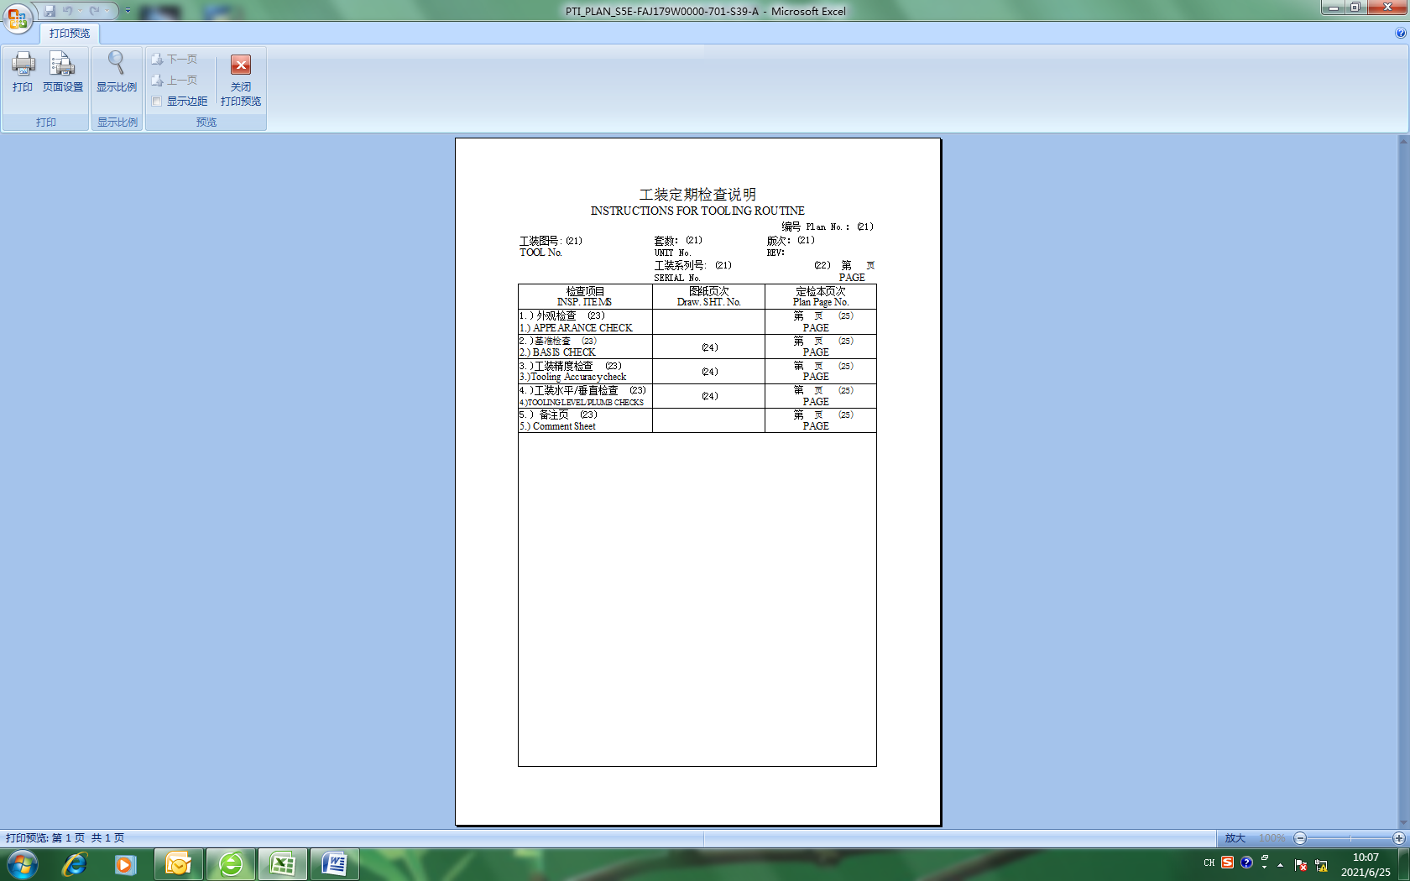

（21）～（25）由工艺装备室技术员填写。
(21) - (25) shall be filled in by the technician of Tooling Office.
（21）：按第1页的相关信息填写。
（22）：填写页次，本页为第2页。
（23）：填写检查项目。包括：外观检查、基准检查、工装精度检查（工具球点、工具球面等）、工装水平/垂直检查（按需）及备注页。
（24）：对于最新版次工装图纸中规定的数据特征，填写对应的工装图纸页次。
（25）：填写检查项目在工装定检计划中的页次。
(21): Fill in according to the relevant information on page 1.
(22): Fill in the page. This page is page 2.
(23): Fill in the inspection items. Including: appearance inspection, benchmark inspection, tooling accuracy inspection (tooling ball point, tooling spherical surface, etc.), tooling horizontal / vertical inspection (as required) and remarks page.
(24): For the data characteristics specified in the latest tooling drawing, fill in the corresponding tooling drawing page.
(25): Fill in the page of the inspection items in the tooling periodic inspection plan.
（未完，见下页）
(See next page)

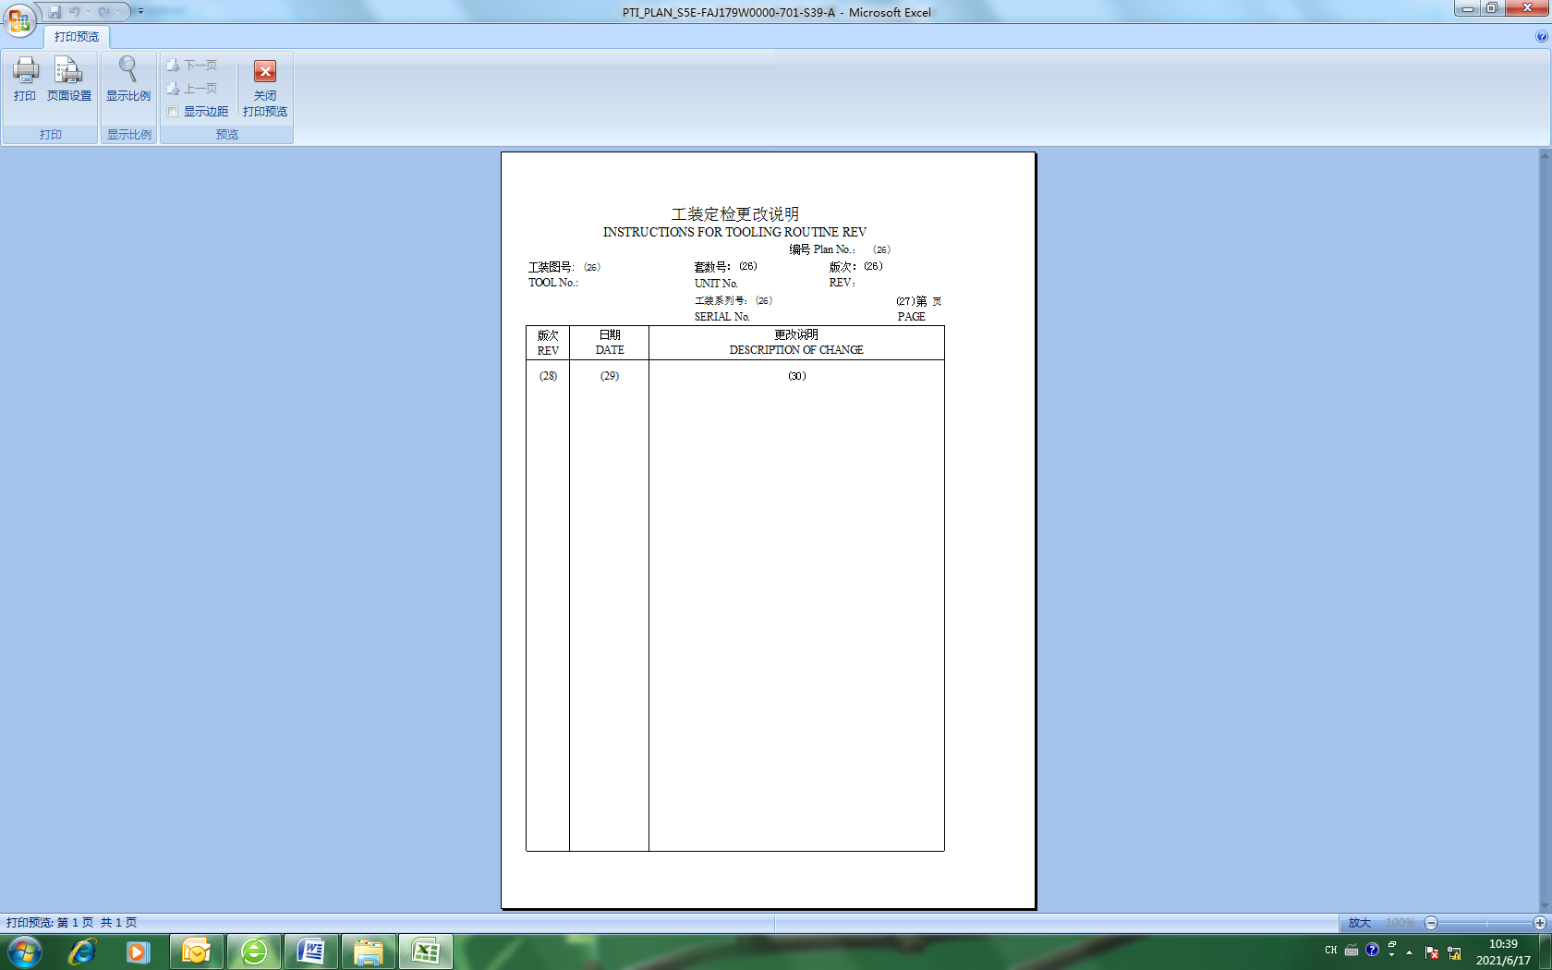
（26）～（30）由工艺装备室技术员填写。
(26) ～ (30) shall be filled in by the technician of Tooling Office.
（26）：按第1页的相关信息填写。
（27）：填写页次，本页为第3页。
（28）：由上至下的填写工装定检计划的所有历史版次和当前版次。
（29）：填写工装定检计划所有历史版次和当前版次的发放日期。
（30）：填写工装定检计划所有历史版次和当前版次的升版说明，NEW版对应的此处填写“原始版”。
(26): Fill in according to the relevant information on page 1.
(27): Fill in the page. This page is page 3.
(28): Fill in all historical and current versions of tooling periodic inspection plan from top to bottom.
(29): Fill in the release date of all historical versions and current versions of the tooling periodic inspection plan.
(30): Fill in the upgrading instructions of all historical and current versions of the tooling periodic inspection plan, and fill in the "original version" corresponding to the new version.
（未完，见下页）
(See next page)

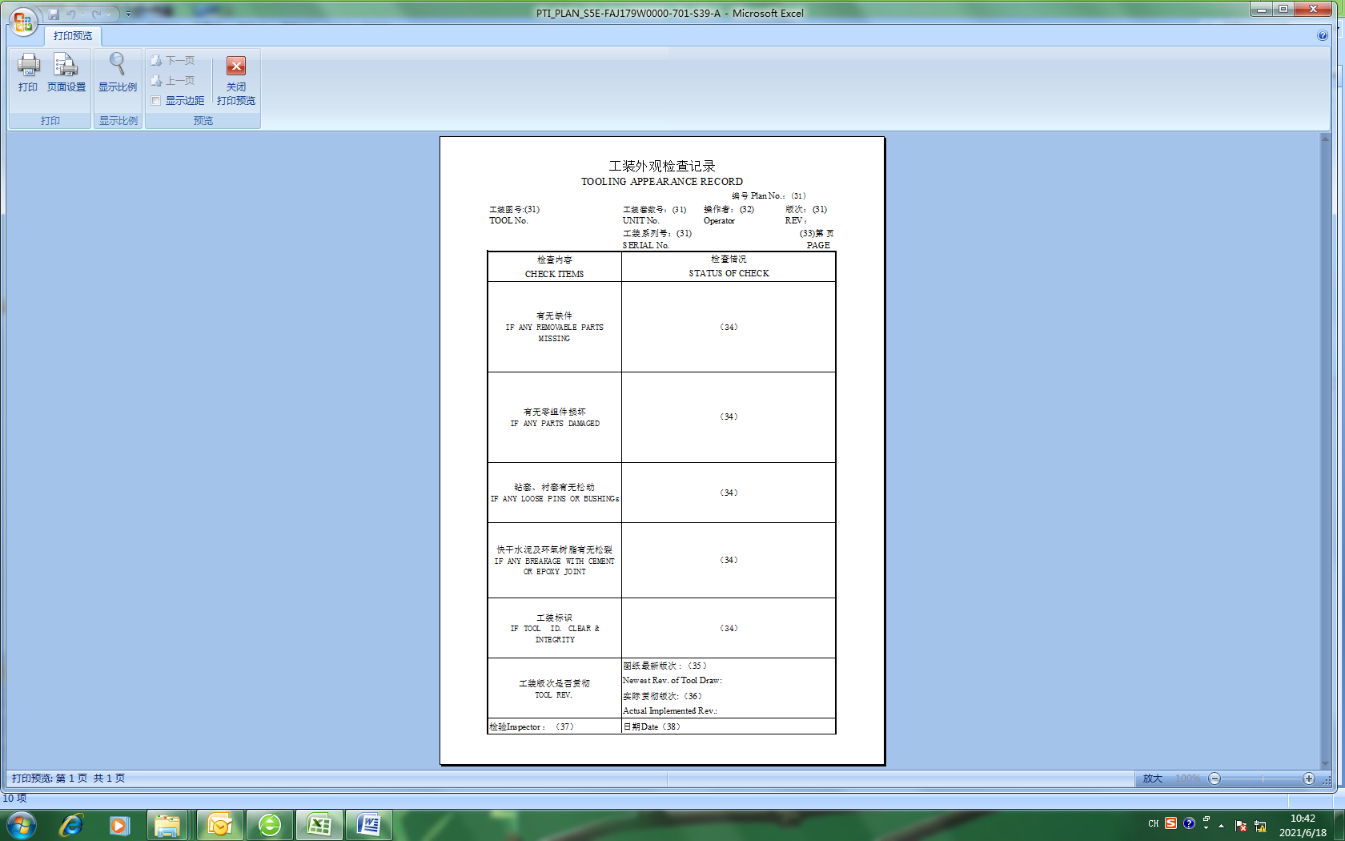
（31）：工艺装备室技术员按第1页的相关信息填写。
（32）：工装定检操作者签字并注明日期。对于工装定查，如测量工装水平/垂直，此栏由工装水平/垂直的测量人员签字并注明日期。如不测量装水平/垂直，定查实施人员在此栏填写“N/A”。
（33）：工艺装备室技术员填写页次，本页为第4页。
（34）：工装定检/定查实施人员按照检查内容填写检查结果。
（35）：工艺装备室技术员填写工装图纸的当前最新版次。
（36）：工装定检/定查实施人员填写工装实物所对应的工装版次。
（37）：工装定检/定查的检验人员盖章。
（38）：工装定检/定查的检验人员填写盖章日期。
(31): The technician of Tooling Office shall fill in according to the relevant information on page 1.
(32): The operator of tooling periodic inspection shall sign and indicate the date. For performing tooling periodical check, if tooling level/plumb is measured, this column is filled by operator measured tooling level/plumb. If tooling level/plumb is not measured, this column shall be filled in "N/A" by the person performed tooling periodical check.
(33): The technician of Tooling Office fills in the page. This page is page 4.
(34): The operator of tooling periodic inspection/check shall fill in the inspection results according to the inspection contents.
(35): The technician in Tooling Office fills in the current latest version of the tooling drawing.
(36): The person who performs tooling periodic inspection/check fills in the corresponding revision of the tooling.
(37): Stamp of the inspector of tooling periodic inspection/check.
(38): The inspector of tooling periodic inspection/check shall fill in and stamp the date.
（未完，见下页）
(See next page)

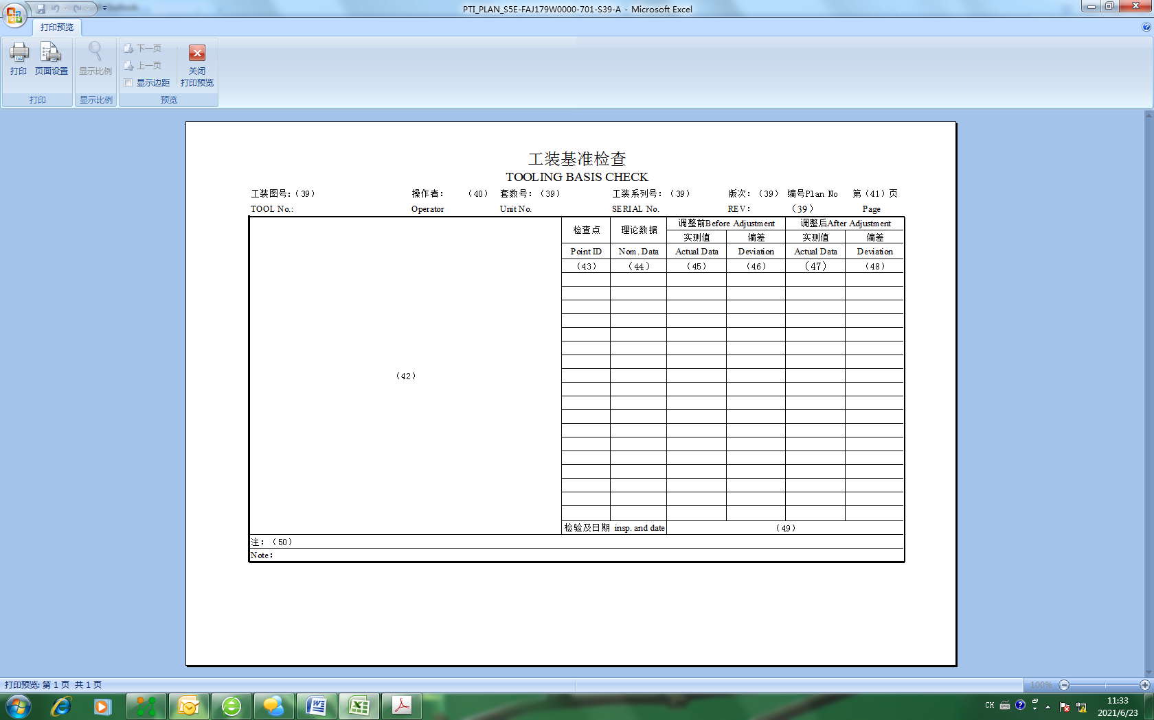
（39）、（41）～（44）以及（50）由工艺装备室技术员填写，（45）～（48）由工装定检操作者填写。
(39), (41) - (44) and (50) shall be filled in by the technician of Tooling Office, and (45) - (48) shall be filled in by the tooling periodic inspection operator.
（39）：按第1页的相关信息填写。
（40）：工装定检操作者签字并注明日期。
（41）：填写页次，本页为第5页。如本页不足以填写所有基准数据，按照本页的排布进行续页。
（42）：推荐在此处通过使用图示来清晰地表达基准的位置。
（43）：由上至下的填写基准特征的名称。
（44）：填写相应基准特征的理论值。
（45）：按照测量设备出具的测量报告填写相应基准特征的测量值。对于一个基准特征有多个测量值的情况，如测量值都不超出公差，填写其中任意一个测量值；如有测量值超差，填写偏差最大的测量值。
（46）：填写相应的偏差。
（47）：如工装定检过程中对基准特征进行返修，按照测量设备出具的测量报告填写返修后基准特征的测量值。对于一个基准特征有多个测量值的情况，参照（45）填写。
（48）：填写相应的返修后测量值的偏差。
（49）：工装定检的检验人员盖章并注明日期。
（50）：填写基准公差，按需填写其它备注信息。
(39): Fill in according to the relevant information on page 1.
(40): The operator of tooling periodic inspection shall sign and indicate the date.
(41): Fill in the page. This page is page 5.If this page is not enough to fill in all benchmark data, continue the page according to the layout of this page.
(42): It is recommended that the position of the datum be clearly expressed here by using diagrams.
(43): Fill in the name of datum characteristics from top to bottom.
(44): Fill in the theoretical value of the corresponding datum characteristics.
(45): Fill in the measured values of corresponding datum characteristics according to the measurement report issued by the measuring equipment. For a datum characteristic with multiple measured values, if the measured values do not exceed the tolerance, fill in any measured value; if the measured value is out of tolerance, fill in the measured value with the largest deviation.
(46): Fill in the corresponding deviation.
(47): If the datum characteristic is repaired during the periodic inspection of tooling, the measured value of the repaired datum characteristic shall be filled in according to the measurement report issued by the measuring equipment. If a datum feature has multiple measured characteristics, fill in with reference to (45).
(48): Fill in the corresponding deviation of the measured value after repair.
(49): The inspector of tooling periodic inspection shall stamp and indicate the date.
(50): Fill in the datum tolerance and other remarks as required.
（未完，见下页）
(See next page)

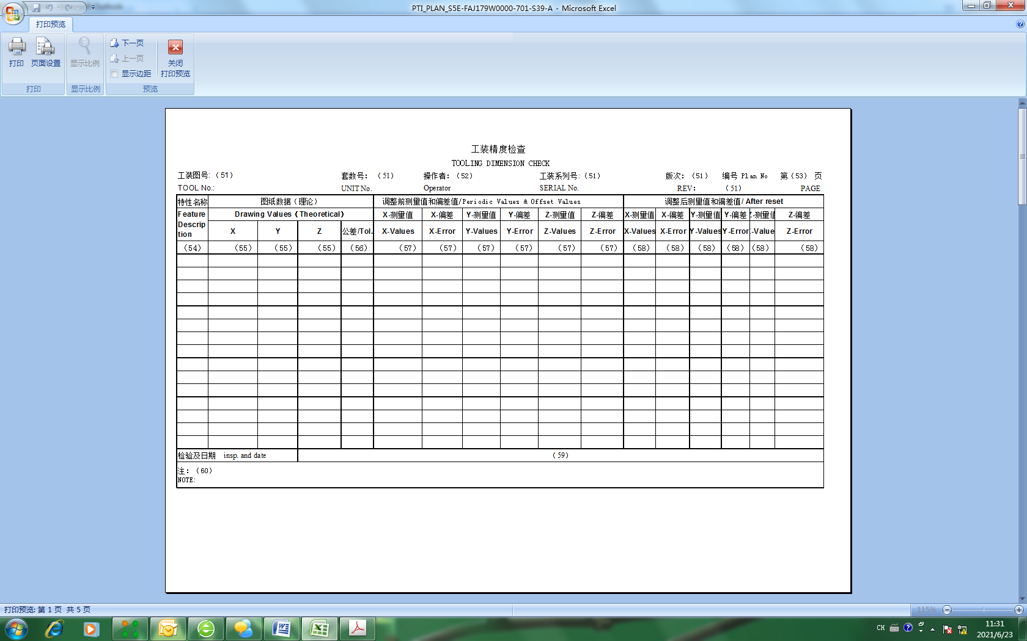
（51）、（53）～（56）以及（60）由工艺装备室技术员填写，（57）和（58）由工装定检操作者填写。
(51), (53) - (56) and (60) shall be filled in by the technician of Tooling Office, (57) and (58) shall be filled in by the tooling periodic inspection operator.
（51）：按第1页的相关信息填写。
（52）：工装定检操作者签字并注明日期。
（53）：填写页次。如本页不足以填写所有测量数据，按照本页的排布进行续页。
（54）：由上至下的填写工具球点的名称。
（55）：填写相应工具球点的理论值。
（56）：填写相应工具球点的公差。
（57）：按照测量设备出具的测量报告填写相应工具球点的测量值和偏差。
（58）：如工装定检过程中对工具球点相关的零件进行返修，按照测量设备出具的测量报告填写返修后的工具球点的测量值。
（59）：工装定检的检验人员盖章并注明日期。
（60）：按需填写备注信息。
(51): Fill in according to the relevant information on page 1.
(52): The operator of tooling periodic inspection shall sign and indicate the date.
(53): Fill in the page. If this page is not enough to fill in all measurement data, continue the page according to the arrangement of this page.
(54): Fill in the name of the tool ball point from top to bottom.
(55): Fill in the theoretical value of the corresponding tool ball point.
(56): Fill in the tolerance of the corresponding tool ball point.
(57): Fill in the measured value and deviation of the corresponding tool ball point according to the measurement report issued by the measuring equipment.
(58): If the parts related to the tool ball point are repaired during the periodic inspection of the tooling, fill in the measured value of the repaired tool ball point according to the measurement report issued by the measuring equipment.
(59): The inspector of tooling periodic inspection shall stamp and indicate the date.
(60): Fill in remarks as required.
（未完，见下页）
(See next page)

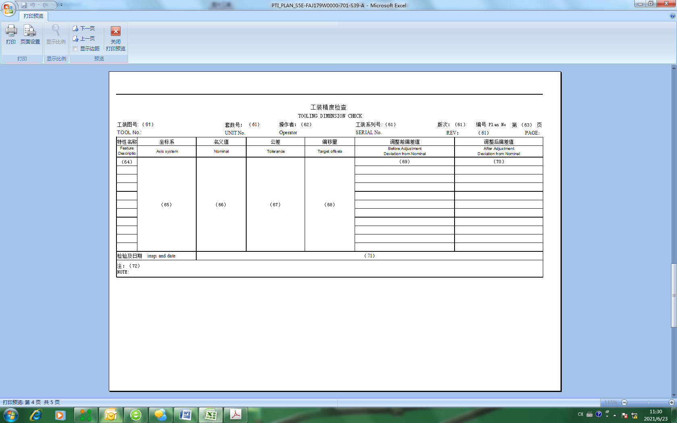
（61）、（63）～（68）以及（72）由工艺装备室技术员填写，（69）和（70）由工装定检操作者填写。
(61), (63) - (68) and (72) shall be filled in by the technician of Tooling Office, (69) and (70) shall be filled in by the tooling periodic inspection operator.
（61）：按第1页的相关信息填写。
（62）：工装定检操作者签字并注明日期。
（63）：填写页次。如本页不足以填写所有测量数据，按照本页的排布进行续页。
（64）：由上至下的填写型面测量点的名称。名称由“OTS-测量件号-该测量件型面测量点的流水号”构成。如型面测量点的分布复杂，在此页编制图示来清晰地表达型面测量点的位置。
（65）：描述测量坐标系。
（66）：填写测量所用的数模名称（含扩展名）和数模版次。
（67）：填写相应型面测量点的公差。
（68）：填写相应型面测量点的偏移量。
（69）：按照测量设备出具的测量报告填写相应型面测量点的偏差。
（70）：如工装定检过程中对型面相关的零件进行返修，按照测量设备出具的测量报告填写返修后的型面测量点的测量值。
（71）：工装定检的检验人员盖章并注明日期。
（72）：按需填写备注信息。
(61): Fill in according to the relevant information on page 1.
(62): The operator of tooling periodic inspection shall sign and indicate the date.
(63): Fill in the page. If this page is not enough to fill in all measurement data, continue the page according to the arrangement of this page.
(64): Fill in the name of the profile measurement point from top to bottom. The name consists of "OTS-measuring part number - serial number of measuring point on the profile of the measuring part". If the distribution of profile measurement points is complex, prepare a diagram on this page to clearly express the location of profile measurement points.
(65): Describe the measurement coordinate system.
(66): Fill in the MBD name (including extension) and MBD used for measurement.
(67): Fill in the tolerance of the measuring point of the corresponding profile.
(68): Fill in the offset of the measuring point of the corresponding profile.
(69): Fill in the deviation of corresponding profile measurement points according to the measurement report issued by the measuring equipment.
(70): If the parts related to the profile are repaired during the periodic inspection of tooling, the measured values of the repaired profile measurement points shall be filled in according to the measurement report issued by the measuring equipment.
(71): The inspector of tooling periodic inspection shall stamp and indicate the date.
(72): Fill in remarks as required.
（未完，见下页）
(See next page)

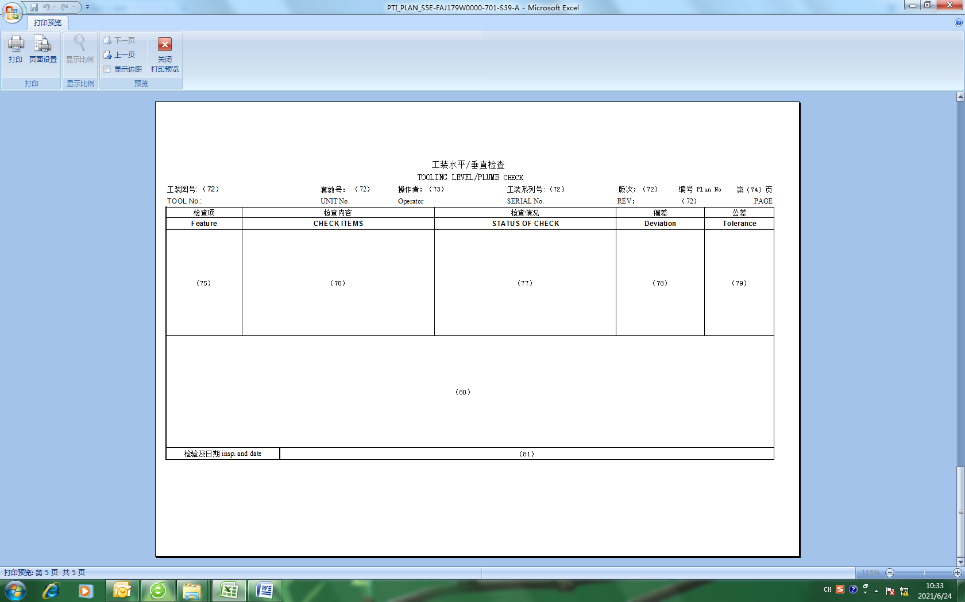
（72）、（74）～（76）、（79）和（80）由工艺装备室技术员填写，（77）和（78）由工装水平/垂直的测量人员填写。
(72), (74) ～ (76), (79) and (80) shall be filled in by the technician of Tooling Office, (77) and (78) shall be filled in by the operator who measured tooling level/plumb.
（72）：按第1页的相关信息填写。
（73）：工装水平/垂直的测量人员签字并注明日期。
（74）：填写页次，本页可以按需与基准检查页合并。如本页不足以填写所有测量特征，按照本页的排布进行续页。
（75）：按需填写工装水平/垂直。
（76）：填写工装水平/垂直的具体检查内容，包括工装水平/垂直检查的触发条件。
（77）：填写检查结果。如未触发工装水平/垂直检查，此栏填写N/A。
（78）：填写工装水平/垂直检查的偏差。
（79）：填写工装水平/垂直检查的公差。
（80）：用图示展示工装水平/垂直检查的具体位置。
（81）：检验人员盖章并注明日期。
(72): Fill in according to the relevant information on page 1.
(73): The operator who measured tooling level/plumb shall sign and indicate the date.
(74): Fill in the page. This page can be merged with the benchmark inspection page as needed. If this page is not enough to fill in all measurement characteristics, continue the page according to the arrangement of this page.
(75): Fill in tooling horizontal / vertical as required.
(76): Fill in the specific inspection contents of tooling horizontal / vertical, including the trigger conditions of tooling horizontal / vertical inspection.
(77): Fill in the inspection results. If the tooling horizontal / vertical inspection is not triggered, fill in N / A in this column.
(78): Fill in the deviation of tooling horizontal / vertical inspection.
(79): Fill in the tolerance of tooling horizontal / vertical inspection.
(80): Show the specific position of tooling horizontal / vertical inspection with a diagram.
(81): The inspector shall seal and indicate the date.
（未完，见下页）
(See next page)

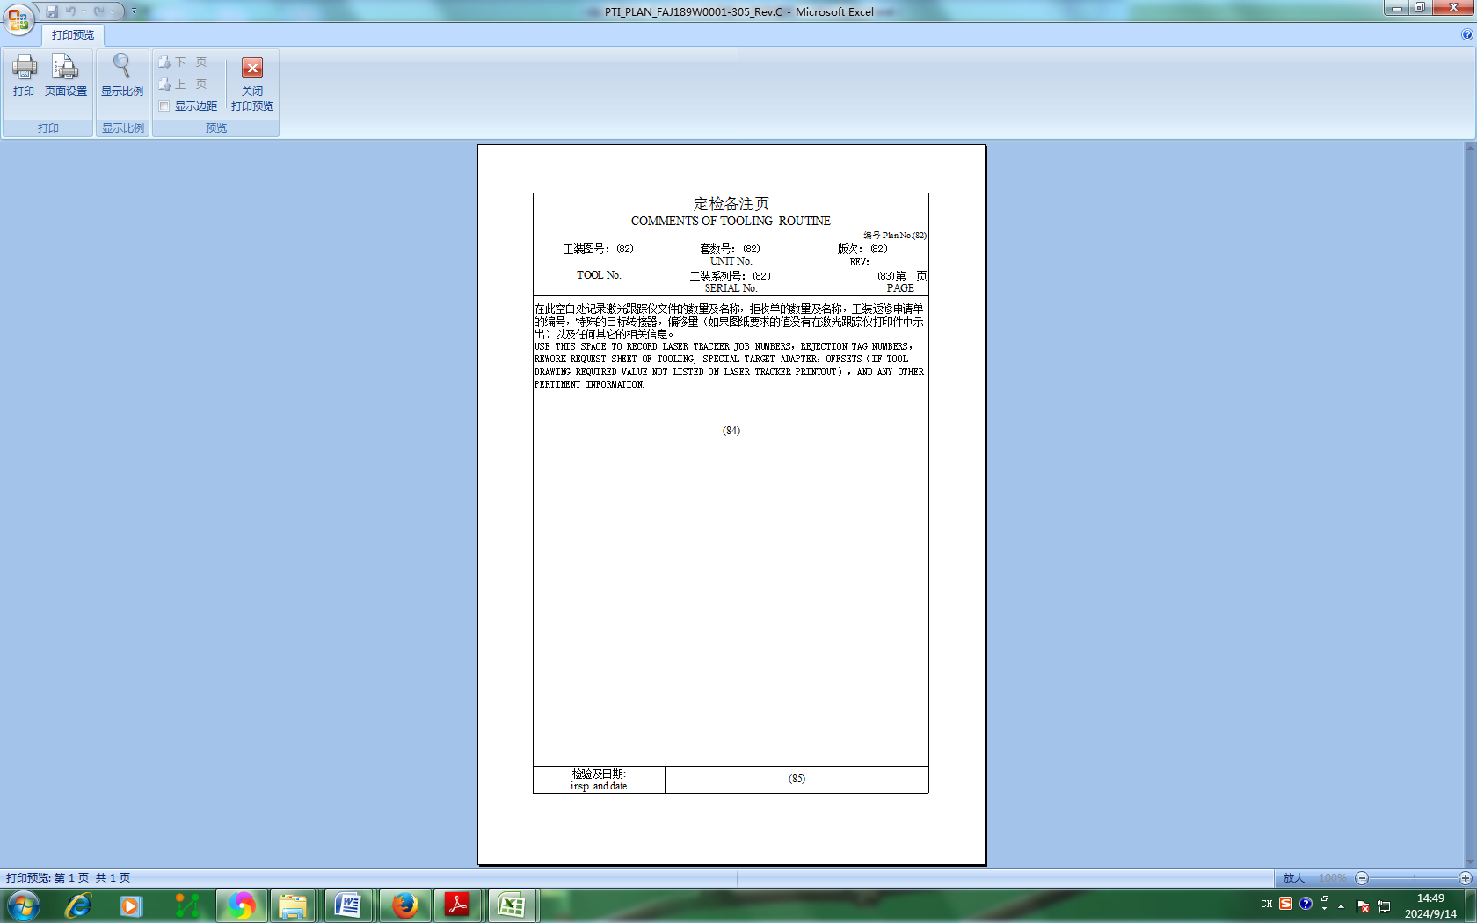
（82）和（83）由工艺装备室技术员填写，（84）由工装定检/定查实施人员填写。
(82) and (83) shall be filled in by the technician of Tooling Office, (84) shall be filled in by the tooling periodic inspection/check operator.
（82）：按第1页的相关信息填写。
（83）：填写页次。
（84）：按此处的要求填写相关信息。
（85）：工装定检/定查的检验人员盖章并注明日期。
(82): Fill in according to the relevant information on page 1.
(83): Fill in the page.
(84): Fill in relevant information as required here.
(85): The inspector of tooling periodic inspection/check shall stamp and indicate the date.

